**Introduction**

Since my childhood, I have always heard the statement, ‘The world bank has granted country b x amount of money….’ And I really used to wonder what that meant. Over time I have come to know the world bank as an international financial institution whose mandate is to reduce poverty and promote economic development, especially in the developing countries. World Bank is owned by 187 countries and has been in operation since 1945. It has taken a huge role in development of developing countries in various sectors such as infrastructure, education, healthcare, nutrition, addressing climate change and natural disasters, among others. The internation development association (IDA) is a branch of the world bank which specializes in the hardest hit nations. It gives them low interest loans known as credits and grants to boost economic growth. The International Bank for Reconstruction and Development (IBRD) is another branch of the world bank that provides loans to middle-income and creditworthy low-income countries, The African continent has a huge number of developing countries including Kenya where I was born. Although I have been hearing of figures borrowed and amount paid across the media, I have never taken a closer look into the numbers and how the money is utilized in detail. Therefore, when I came across the data, I decided to dig deep into it and analyze the significant contributions the world bank has made to Kenya and Africa at large.

**The data**

The data is from the World Bank Group – International Bank for Reconstruction and Development (IBRD) and was updated on May 9th, 2025. This data is kept up to date quarterly by the World Bank. There are 1,425, 399 rows and 30 columns of IBRD credits or grants in this dataset. You may check out the data [**here.**](https://finances.worldbank.org/Loans-and-Credits/IDA-Statement-Of-Credits-and-Grants-Historical-Dat/tdwh-3krx)

**KEY TAKEAWAYS:**

In this project I undertook the task of analyzing the World Bank’s most recent data to give an update on current lending as of 17th May 2025

1. There are 156 countries receiving assistance from the IBRD.

2. There are 1,417,391 loans funded by the IBRD

3. The total amount of loans funded by the IBRD is $33,019,041,852,934 (33 trillion USD)

4. The top ten countries with the greatest amount owed to the World Bank are listed below with Indonesia, India, Mexico, and Brazil leading the list.

5. In Africa, South Africa and Zimbabwe leading the list of the largest amount owed.

6.  The IBRD has given the Kenya 10,440 loans.

7.   Kenya received a total of $13,213,688,738 and owes 0.04% of the total amount of funds loaned by the IBRD.

8.    Kenya has repaid $166,615,978,684 to the IBRD

9.    The IBRD has cancelled $46,834,314,637 of Kenya’s' loans.

10.    The top ten projects funded by the IBRD in Kenya are aimed financial sector reforms and governance, fiscal growth nutrition, sugar production, highway infrastructure and power.

THE SQL ANALYSIS

SQL is a powerful tool for handling large datasets, like the one we are working with that has over a million rows. Even though the SQL commands used were simple, it was exciting to be able to explore such a massive amount of data.

KPIs

1. Number of countries receiving assistance from the World Bank

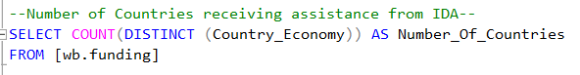

1. Number of loans funded by IBRD

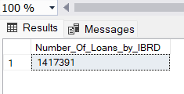

1. The total amount of loans funded by the IBRD

1. Top ten counties with the greatest amount owed to IBRD.

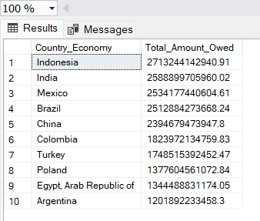

1. Top 10 African counties with the greatest amount owed to IBRD.

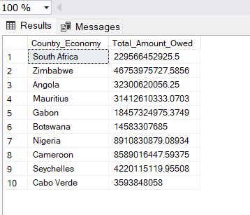

1. Number of loans funded to Kenya by IBRD

\

1. What is the total amount currently owed to the World Bank by Kenya?

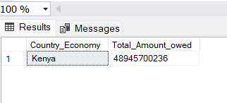

The total amount that Kenya owes IBRD is $48.9 billion

1. Total amount that Kenya has paid back to the World Bank

Kenya has repaid a total of $166.6 billion.

1. Total amount of Kenya’s loan cancelled by IDBR.

--Total Amount of Kenya's loan cancelled by IBDR--

SELECT Country_Economy, SUM(Cancelled_Amount_US) AS Total_Amount_Cancelled

FROM [wb.funding]

WHERE Country_Economy LIKE 'Kenya'

GROUP BY Country_Economy

The IBDR has cancelled a total of $ 46.8 billion of Kenya’s loans.

1. Top ten projects funded by IBDR in Kenya

--Top ten projects funded by IBDR in Kenya--

SELECT TOP 10 Project_Name, MAX(Original_Principal_Amount_US) AS Funding

FROM [wb.funding]

WHERE Country_Economy LIKE 'Kenya' AND Project_Name IS NOT NULL

GROUP BY Project_Name

ORDER BY MAX(Original_Principal_Amount_US) DESC

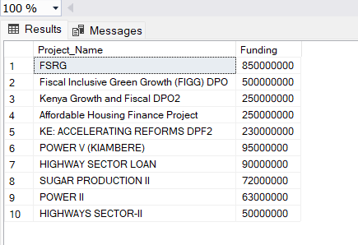

Top fundings go towards reforming the financial sector, economic recovery and resilience to future shocks and affordable housing projects. There is also funding towards infrastructure and the sugar production sector.

1. Top ten projects funded by IBDR in Japan

--Top ten projects funded by IBDR in Kenya--

SELECT TOP 10 Project_Name, MAX(Original_Principal_Amount_US) AS Funding

FROM [wb.funding]

WHERE Country_Economy LIKE 'Kenya' AND Project_Name IS NOT NULL

GROUP BY Project_Name

ORDER BY MAX(Original_Principal_Amount_US) DESC

Top fifteen projects in Spain

Top fifteen projects in Italy

Top ten projects in Nigeria

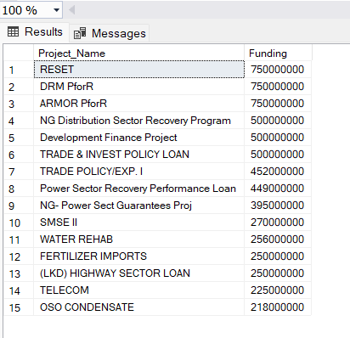

CONCLUSION

This learning experience has been truly humbling, especially in understanding the scale and impact of the World Bank’s operations across the globe. It is remarkable to see the extensive support it provides to both developed and developing nations. One key insight I have gained is the distinct focus of funded projects: developed countries—such as Japan, Spain, and Italy—often prioritize industrial growth and infrastructure development, whereas developing countries—like Kenya and Nigeria—tend to concentrate on financial and economic reforms. These perspectives have been incredibly enriching to my data learning journey, and I am deeply grateful for the opportunity to explore and grow through this experience. Thank you for being part of it.